**WORLD ENVIRONMENT DAY**

|  |  |
| --- | --- |
|  |  |

SOUVENIR

**SEMINAR**

**ON**

**“Air Pollution”**

**5TH JUNE 2019**

THE INSTITUTION OF ENGINEERS (INDIA)

MUZAFFARPUR LOCAL CENTRE

**(FOUNDED 1969)**

**MUZAFFFARPUR INSTITUTE OF TECHNOLOGY**

**MUZAFFARPUR – 842003 (BIHAR), Web: ieimuz.org**

Er. Narendra Kumar Jha, MIE Dr. Anjani Kumar Mishra, FIE

Hon. Secretary Chairman

**The Institution of Engineers (India)**

**Muzafffarpur Local Centre**

**M.I.T., Muzaffarpur-842003 (BIHAR**)

**2019**

***ROLL OF HONOUR***

**YEAR CHAIRMAN**  **HON. SECRETARY**  **JOINT HON. SEC.**

1969-70 Er. K.P. Agrawal Prof. I.C. Nayak

1970-70 Er. R.P. Agrawal Er. K.R. Rajagopal

1971-72 Er. S. Prasad Er. K.R. Rajagopal

1972-73 Er. S. Prasad Er. K.R. Rjagopal

1973-74 Er. K.R. Rajagopal Er. R.P. Jayaswal

1974-75 Er. M.A. Samad Er. R.P. Jayaswal

1975-76 Er. M.A. Samad Er. R.P. Jayaswal

1976-77 Dr.B.P Sinha Er. J.S Prasad Er. J.S. Prasad

1977-78 Dr. B.P.Sinha Er. K. Prasad Dr. K. Prasad

1978-79 Er. R.K. Sinha Dr. K. Prasad

1979-80 Prof. R.P. Sinha Er. B.B. Prasad

1980-81 Prof. R.P. Sinha Er. B.B. Prasad

Er. J.S. Prasad

1981-82 Prof. R.P.Sinha Er. I.S. Prasad

1982-83 Er. G.M. Sahai Er. I.S. Prasad

1983-84 Prof. R.K. Garg Er. B.P. Sahani’Arun’ Er. M. Qutuba

1984-85 Er. Y.P. Sharma Er. B.P. Sahani’Arun’

1985-86 Er. Y.P Sharma Er. B.P. Sahani’Arun’

1986-87 Dr. U.N. Sharan Er. B.P. Sahani’Arun’

1987-88 Dr. U.N. Sharan Dr. H.P. Sinha

Dr. M.K. P. Mishra Dr. H.P. Sinha

1988-89 Dr.B.B. Prasad Prof. S.N.P. Srivastava

1989-90 Dr. B.B. Prasad Prof. S.N.P. Srivastava

1990-91 Prof. B.P. Sahani’Arun’ Prof. S.N.P. Srivastava Prof. A.K. Nathani

1991-92 prof. B.P. Sahani’Arun’ Dr.H.P. Sinha

1992-93 Er. S.K.P. Verma Dr. H.P. Sinha

1993-94 Er. S.K.P Verma Dr. R.C Das ‘Vikal’

1994-95 Dr. U.C. Verma Dr. R.C. Das ‘Vikal’

1995-96 Dr. U.C. Verma Dr. R.C. Das ‘Vikal’

1996-97 Dr. U.C. Verma Dr. R.C. Das ‘Vikal’

1997-98 Dr. R.C. Das ‘Vikal’ Dr. B.K. Prasad

1998-99 Dr. R.C. Das ‘Vikal’ Dr. B.K. Prasad

Er. U. R. Sinha Dr. B. K. Prasad

1999-2K Prof. Bhola Sahu Dr. B. K. Prasad

2K-2K1 Prof. Bhola Sahu Dr. B.K. Prasad

2K1-2K2 Dr. B.K. Prasad Dr. Achintya

2K2-2K3 Dr. B.K. Prasad Dr. Achintya

2K3-2K4 Dr. R. Pandey Prof. Suresh Kumar

2K4-2K6 Er. V.N. Sahu Dr. A. K. Rai

2K6-2K8 Dr. Achintya Prof. C.B. Rai

2K8-2K10 Dr. Suresh Kumar Dr. Sunil Kumar

2k10-2K12 Dr. A. K. Rai Er. S.K Tiwary

2K12-2K14 Prof. C.B.Rai Er. Jayant Ajat Shatru

2K14-2K16 Dr. Sunil Kumar Er. A.P Singh

2K16-2K18 Er. S.K. Mishra Dr. Rajeev Ranjan Kumar

2K18-2K20 Dr. Anjani Kumar Mishra Er. Narendra Kumar Jha

THE INSTITUTION OF ENGINEERS (INDIA)

MUZAFFARPUR LOCAL CENTRE

M.I.T., MUZAFFARPUR-842003

**2019**

***CONTENTS***

**Sl. No. Page No.**

1. **Roll of Honour**
2. **Paper Presented by**
3. Dr. Anjani Kumar Mishra 2-4
4. Er. Narendra Kumar Jha 5-8
5. Dr. Anjani Kumar Srivastava 9-14
6. Prof Sanjay Kumar Chaudhary 15-17
7. Er. Lok Ranjan 18-20
8. Porf. Prabhat Ranjan Bhardwaj 21-24
9. Er. Rahul Kumar 25-26
10. Er. Krishan Kanhai 27-30
11. Suyasta Kumari 31-33
12. Diksha Kumari 34-36
13. Er. Santosh Kumar Lal  37-38
14. Local Centre Committee Member of 2016-2018

**Air Pollution**

Dr. Anjani Kumar Mishra

Principal, Govt. Polytechnic

Deptt. Of Science and Technology, Bihar

**Abstract**

On the eve of world environment day, air pollution is great concern to scientist to protect human beings, plants, animals living in our planets. Air pollution creates smog and acid rains, causes respiratory diseases, affects crop yields, water purity and its availability, reduces the ozone layer atmosphere which contributes to global warming.

In this phase of development to meet the requirement of country to stand at par to other countries of the world, air pollution cannot be eliminated completely, but policies and action plans can reduce its percentage’s. The Government has developed and continues to develop norms and guidelines for air quality and its ordinances to control air pollution. On individual effort, we can contribute to minimize air pollution by using high efficient bulbs, fans and other appliances, electric vehicles, wastes disposal in such a manner that it should not pollute environment, highly toxic gases fumes, chemical wastes should undergo primary treatment before releasing all in the environment. Industrial area should be fully cared so that no pollutant can effect environment. Awareness, sensitization of systems, educating youths, children to protect our environment by making laws, ordinance, changing living style can prevent air pollution.

**Key words:** Pollution, environment, protection.

**Introduction**

The aim of world environment day is to protect our environmentand encouraging worldwide awareness. World environment day was established in 1972 during the United conference on the Human Environment which led to the creation of the United Nations Environment programme (UNEP) since its inception. WED has developed global platform for raising awareness and taking action years after year , the aim of world Environment Day is giving face to environment issues. The Government of India has also driven the “ Swachta abhiyan” in every Govt. organization and educational institution. Even private sectors are taking action to protect environment by many ways. We have to raise people awareness to protect environment, not to raise the sea level due to effect of global warming.

The air pollution even causes premature death. As per survey seven million people die worldwide in which four million of these deaths occurring in Asia-Pacific. World environment day 2019 will urge governments, industry, communities and individuals to come together to explore renewable energy and green technologies, to improve air quality in cities and regions across the world. Only way to meet the solution of air pollution is to grow green energy sector. The other way is to prevent the environment form different source of polluting factors mostly form industries, transportation system and chemical hazards spreading in our day to day routine of life.

The facts of air pollution is of great concern to human beings 92 percent of people worldwide don’t breathe clean air. Air pollution costs the global economy about $5 trillion every year in welfare costs. Ground-level ozone pollution is expected to reduce staple crop yields by 26 percent by 2030. The United Nation is the leading global voice on the environment. Our county should also encourage partnership in leading caring the environment by inspiring, spreading the consequences of air pollution and enabling states and peoples to improve their quality of life. The government organization should work with NGO’s, private sector, civil society and with other UN entities and international organization across the world.

**Main thrust**

There are different types of air pollution created to affect environment. The air pollution are either manmade or natural. The manmade sources of pollution are mostly related to burning of different kinds of fuel. This also includes smoke of power plant, manufacturing process of tools and machines, treatment of water. Measure sources of air pollution are fossil fuels, wood, crop waste and cow dung. The other sector of air pollution is transportation means. The motor vehicle, marine vessels, air craft and the effect of sound etc. chemicals, dust and other techniques of farming, fire control process in forest management are also manmade air pollution. Waste deposition in landfills which emits methane and pollute air, nuclear weapons, toxic gases germ warfare and rocketry are also manmade pollution for environment. Natural sources of air pollution are dust arising from large areas of land with few and no vegetation. Methane gas emitted by the digestion of food by animals. Smoke and carbon monoxide from wildfires. Radon gas from radioactive decay within the Earth’s crust. Radon is colorless odorless, naturally occurring radioactive noble gas that is formed form the radium. Radon gas from natural sources can cause lung cancer and accumulate in the area like basement of a building. Air polluting volcanic eruption, which produces sulfur, chlorine and ash particulate vegetation in some regions emits environmentally significant amount of volatile organic compounds (VOCs) in warmer days. These VOCs reacts with NO2, SO2 and other organic compounds to produce seasonal hazard of pollutants for air.

**Air Pollution Facts**

* India is a country with the worst air quality in the world
* There are no ways to protect air pollution from pollutants emitting form cars, buses, motorcycles and other heavy vehicles on the road.
* Standards have been developed to protect air pollution by vehicles from manufacturing industries still older vehicles are running without following any standards.
* The average adult breathes 3,000 gallons of air every day.
* Air pollution effect kids due to excessive concentration of pollutants as per their body size.
* In large cities over 80% of fatal pollutants are due to running vehicles i.e. transportation system.
* According to the world health organization there are as many deaths (1.3 million per year) in the world due to air pollution.
* The great smog of London in 1952 was one of the worst air pollution events in history with over 8,000 deaths.

**Conclusion**

The government of china has committed to organize world environment day in many cities of its country. Likewise government of India should plan to organize seminar and workshops in different states of country covering capitals districts and blocks. The seminar and workshops should cover the topic relating to prevent air pollution and major drive to protect environment from threats developing day by day in the present scenario of development. Air pollution is a global emergency affecting everyone. Electric vehicles, plantation of trees in cities having dense pollution, ban on plastics items, Safety measure devices in running condition for chemical industries, suction pumps just below the chimney’s emitting fly ash and other tiny particles along with fumes should be installed and their disposal are the ways to protect air pollution. There should be action plan for collecting kitchen wasted in two forms i.e. dry and wet. The hospitals wastes should be destroyed with high technology equipments, so that environment should be protected in all the ways. The electronic waste have many do’s and don’t and we should follow it with great care. The industrial waste like fly ash which should be disposed in slurry form and for by products utilization industries should be established near by such plants. Various types of other industrial wastes should be treated in proper manner just to prevent and protect air and water. Our country should demonstrate the ways in tackling air pollution domestically. Thus implementing may technology policies which could reduce 20 percent reduction in carbon dioxide and 45 percent reduction in methane emissions globally, leading to a third of degree Celsius saving a global warming.

**Refrences**

1.U.N. Environment-Press release,Narobi,15 March 2019.

2. U.N.Environment programme-5 June 2108.

3. Causes consequences and control of air pollution-Dr. Manohar Pratap Chaudhary, Associate Professor, RTU Kota, Rajasthan, Vaibhav Garg, Assistant Professor, RTU Kota, Rajasthan,

**AIR POLLUTION IN THE CITY**

**ER. NARENDRA KUAMR JHA, MIE DOORDARSHAN KENDRA**

**MUZAFFARPUR**

The contamination of air due to particles, gases and biological molecules that can reach harmful concentration is termed as air pollution. Air is basic constituents for living things. Oxygen is life. It is termed as “pranvayu”. Healthy air makes us healthy. If we do deep breathing in healthy air many diseases will go away fron our body. Pranayam is the process of curing body by controlled breathing of healthy air. Without air we will not survive for more than one or two minutes. Today it is a big challenge for human being to make air pollution free. Some data are are below.

91% of the world’s population lives in places where air quality exceeds WHO guideline limits.

4.2 million Deaths every year as a result of exposure to ambient (outdoor) air pollution

13 of the world's 20 cities with the highest annual levels of air pollution are in India.

Air pollution contributes to the premature deaths of 2 million Indians every year.

Indian cities that registered very high levels of PM2.5 pollutants are Delhi, Patna, Agra, Muzaffarpur, Srinagar, Gurgaon, Jaipur, Patiala and Jodhpur. Air pollution level in Muzaffarpur is very alarming. According to Air quality report jointly by IQ air Air visual and Greenpeace annual average of PM 2.5 concentration is at 113.3 microgm/m^3.

The major sources of air pollution in Muzaffarpur are road dust, vehicle emission, domestic fuel burning, clinkers, construction, open waste burning, spreading of sewage mud on road, uncovered soil, sand, cement concrete carrying by tractors, old vehicles and increasing no of vehicles mainly three wheelers. It is observed that up to 2018, the air quality of the city during winter becomes very poor due to concentration of particulate matter in the lower portion of the atmosphere but in summer 2019 the situation is continued. It is very alarming for us. The main pollutants in Muzaffarpur city is PM 2.5, P.M.10,SO2 and NO2. Road dust (14-19%), generator sets (5-6%), open waste burning. Last year, Muzaffarpur was witnessed with the worst air quality with PM2.5 recorded at 985 μg/m3, which was over 16 times higher than the national standard. It was observed that more than half of the days (58%) in Muzaffarpur had bad air quality.  ..

The details of these pollutants are below:-

1. **Particulate Matter 2.5 (PM 2.5)** :- It is the mixture of solid particles and liquid droplets in the air.  It can be either human-made or naturally occurring. Some examples include dust, ash and sea-spray. Particulate matter (including soot) is emitted during the combustion of solid and liquid fuels, such as for power generation, domestic heating and in vehicle engines, various industrial process, crustal dust. Particulate matter varies in size (i.e. the diameter or width of the particle). PM**2.5**means the mass per cubic metre of air of particles with a size (diameter) generally less than 2.5 micrometers (µm). PM2.5 is also known as fine particulate matter. Inhalation of particulate pollution can have adverse health impacts.  The biggest impact of particulate air pollution on public health is understood to be from long-term exposure to PM2.5, which increases the age-specific mortality risk, particularly from cardiovascular causes. Several plausible mechanisms for this effect on mortality have been proposed, although it is not yet clear which is the most important.  Exposure to high concentrations of PM (e.g. during short-term pollution episodes) can also exacerbate lung and heart conditions, significantly affecting quality of life, and increase deaths and hospital admissions. Children, the elderly and those with predisposed respiratory and cardiovascular disease, are known to be more susceptible to the health impacts from air pollution.
2. **Particulate matter 10 (PM10)**:- PM10 is particulate matter 10 micrometers or less in diameter. Particles in this size range make up a large proportion of dust that can be drawn deep into the lungs. Larger particles tend to be trapped in the nose, mouth or throat via cilia and mucus, but particulate matter smaller than about 10 micrometers, can settle in the bronchi and [lungs](https://en.wikipedia.org/wiki/Lung) and cause health problems.
3. **Ozone**:- Ozone occurs both in the Earth's upper atmosphere and at ground level. Ozone at ground level is a harmful air pollutant, because of its effects on people and the environment, and it is the main ingredient in “smog." ground level ozone, is not emitted directly into the air, but is created by chemical reactions between oxides of nitrogen (NOx) and volatile organic compounds (VOC). This happens when pollutants emitted by cars, power plants, industrial boilers, refineries, chemical plants, and other sources chemically react in the presence of sunlight. Ozone is most likely to reach unhealthy levels on hot sunny days in urban environments. Ozone in the air we breathe can harm our health. People most at risk from breathing air containing ozone include people with asthma, children, older adults, and people who are active outdoors, especially outdoor workers. Breathing ozone can trigger a variety of health problems including chest pain, coughing, throat irritation, and airway inflammation. It also can reduce lung function and harm lung tissue.
4. **Sulphur dioxide (SO2)**:- It is invisible and has a nasty, sharp smell. About 99% of the sulfur dioxide in air comes from human sources. The main source of sulfur dioxide in the air is industrial activity that processes materials that contain sulfur, e.g. the generation of electricity from coal, oil or gas that contains sulfur. Sulfur dioxide affects human health when it is breathed in. It irritates the nose, throat, and airways to cause coughing, wheezing, shortness of breath, or a tight feeling around the chest. The effects of sulfur dioxide are felt very quickly and most people would feel the worst symptoms in 10 or 15 minutes after breathing it in.
5. **Nitrogen dioxide (NO2)**:- Nitrogen dioxide is an irritant gas. Nitrogen dioxide is an important air pollutant because it contributes to the formation of photochemical smog, which can have significant impacts on human health. The major source of nitrogen dioxide in is the burning of fossil fuels: coal, oil and gas. Most of the nitrogen dioxide in cities comes from motor vehicle exhaust (about 80%).This can cause problems such as wheezing, coughing, colds, flu and bronchitis.
6. **Carbon Monoxide (CO)**:- It is a colorless, odorless, tasteless, and toxic air pollutant—is produced in the incomplete combustion of carbon-containing fuels, such as gasoline, natural gas, oil, coal, and wood. Breathing the high concentrations of CO typical of a polluted environment leads to reduced oxygen (O2) transport by hemoglobin and has health effects that include headaches, increased risk of chest pain for persons with heart disease, and impaired reaction timing.

The few solutions to reduce to reduce Air Pollution in the city are:-

1. **Better maintenance of road**:-The main reason of dust in the city is poor maintenance of road. Due to broken road and poor quality of road construction materials dust particles generated easily which is the main reason of pollution. Well maintained road can reduce dust particles, less time of travelling which will reduce emission of smoke from vehicles. Provision of footpath must be with all roads. Comfortable walking environment may motivate people to walk for some distance. Shortest route should be discovered to reduce traffic congestion and emission. Spreading of sewage mud, construction materials on road must be punishable.
2. **Improvement in Transportation System**:-

* Three wheeler should be replaced by e-rickshaw or CNG or other environmental friendly fuel based transport.

* Traffic management system should be improved to reduce congestion.

* Public transport system should be encouraged.

* Transportation of sand, soil, cement or other construction material should be carried out by completely covered vehicles.

* Ban on old vehicles that completed their life.

* Checking of emission of vehicles on regular basis.

* Checking of fuel adulteration.

1. **Plantation**:-As we know that plants take carbon dioxide and emits oxygen. Other benefits of plant is it gives shadow, stops soil erosion hence reduced dust, maintain ground water level etc. Hence plantation is very necessary. Quality of air will improve if green area in the city will increase.
2. **Use of renewable sources of energy**: - Fossil fuels and coals are the main contributors to air pollution .Opting alternative energy sources to produce power presents particle solution to air pollution. Natural gas, fuel cells and batteries can be better substitute of fossil fuels.
3. **Awareness program**: - Awareness creation will make people to realize and understand the sources and effects of air pollution. From this point, it makes it easier for people to take personal or collective initiatives to reduce air pollution. It can simply be done through an educative process that helps people realize the causes and effects of air pollution.

Ref: 1.<http://timesofindia.indiatimes.com/articleshow/66776365.cms?utm_source>

2. BSPCB website Technical Report on Muzaffarpur.

3. WHO website.

4. Wikkipedia.

**\*\*\*\*\*\*\***

**Air Pollution**

**Er. Anjani Kumar Srivastava, FIE**

Ex – Teacher Fellow, BIT Sindri

Ex-Dy. General Manager, HAL Lucknow

Member, Aeronautical Society of India

**“THERE IS SO MUCH POLLUTION IN THE AIR NOW THAT IF IT WERE NOT FOR OUR LUNGS THERE WOULD BE NO PLACE TO PUT IT ALL”----ROBERT ORBEN**

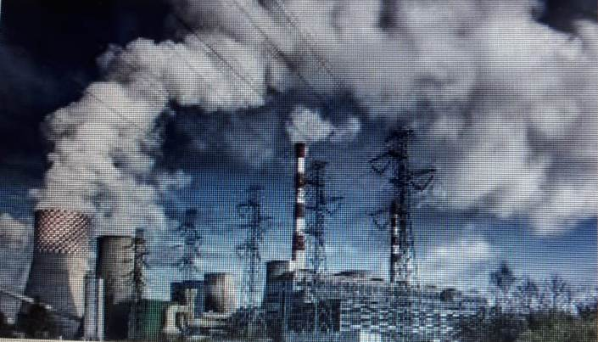

**INTRODUCTION**

When air is contaminated by unwanted substances which have harmful effect on both living and the non-living organisms, it is referred to as “Air Pollution”

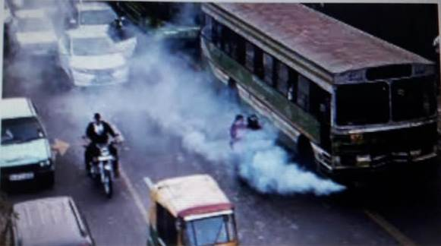 Air pollution is a global emergency affecting everyone .Approximately 7 million people worldwide die prematurely each year from air pollution, with about 4 million of these deaths occurring in Asia-Pacific region. 9 out of 10 persons do not breathe clean air. Diseases like asthma, lung cancer, irritation reaction, heart and brain damages are probably due to adverse effect of high concentration of air pollutants.

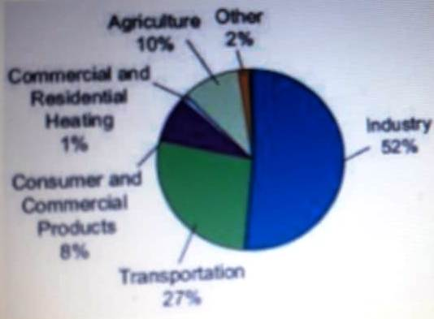**How does air get polluted?**

The substances which contaminate the air are called air pollutants such as carbon monoxide (CO), nitrogen oxide (NO), sulphur dioxide (SO2), particulate matter (PM) and lead oxide which damage environment.

The sources of air pollutants are industries, power plants, automobile exhaust, burning of agricultural wastes and domestic fuel. Sometimes such substances may come from natural sources like 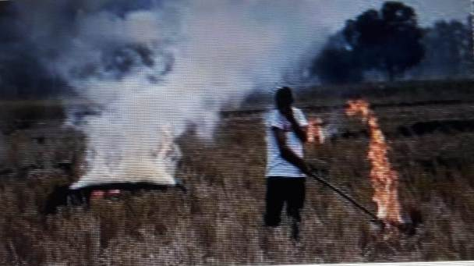smoke and dust arising from forest fires or volcanic eruptions. Vehicles produce high levels of pollutants like carbon monoxide, nitrogen oxides and smoke .Many industries are also responsible for causing air pollution .Petroleum refineries are a major source of gaseous pollutants like sulphur dioxide and nitrogen dioxide.

There has been increased population density in the cities causing more pollution and also because sites for urban development and industrialization have been incorrectly chosen. These factors have exaggerated the pollution.

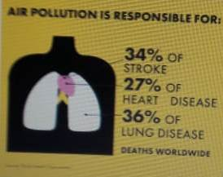**Effects of Air Pollution on Environment**

Air pollution has both direct and indirect impact on human body, animal life ,climate and entire ecosystem. These effects have both long –term and short-term implications and influence the economy and welfare of the human beings.

**GLOBAL WARMING**

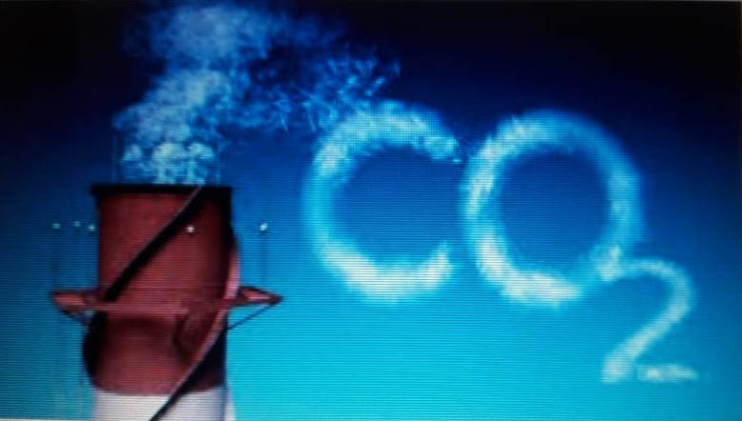Global warming has become a major cause of concern worldwide.CO2 is one of the components of air. But if there is excess of CO2 in the air, it acts as a pollutant. Deforestation leads to an increase in the amount of CO2 in the air because the number of trees which consume CO2 is reduced. CO2 traps heat and does not allow it to escape into space. As a result, the average temperature of earth’s atmosphere is globally increasing. This is called “Global Warming”.

There was recently a report that Gangotri glacier in the Himalayas has started melting because of global warming. Global warming causes sea level to rise dramatically. Global warming could result in wide ranging effects on rainfall patterns, agriculture, forests, plants and animals.

**ACID RAIN**

Acid rain is a result of air pollution. Some of these particles (especially nitrogen oxides and sulphur dioxide) react with tiny droplets of water in clouds to form sulphuric and nitric acids. The rain from these clouds then falls as very weak acid –known as Acid Rain.

**OZONE LAYER DEPLETION**

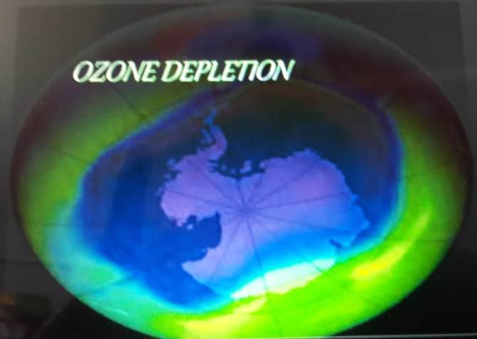Ozone layer depletion is wearing out of the amount of ozone (O3) in Stratosphere. Ozone depletion is a major environment problem because it increases the amount of ultraviolet (UV) radiation that reaches Earth’s surface. These wavelengths cause skin cancer, sunburn, eye cataracts and genetic and immune system damage.

**SMOG**

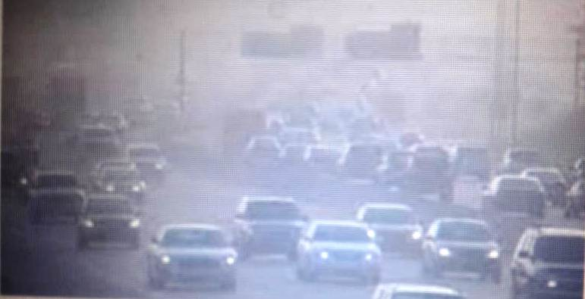This is made up of smoke and fog. A thick fog like layer in the atmosphere especially during winter. Smoke may contain oxides of nitrogen which combine with other air pollutants and fog to form SMOG. The smog causes breathing difficulties such as asthma, cough and wheezing in children.

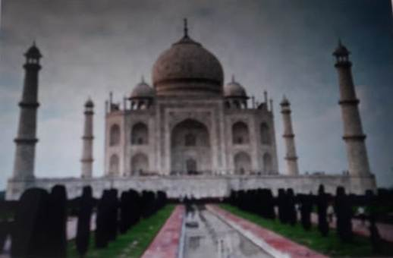**CASE STUDY---**

**The Taj Mahal**

Experts have warned that the pollutants in the air are discoloring the white marble of Taj Mahal in Agra. So, it is not only living organisms that get affected by polluted air but non-living things like buildings, monuments and statues also get affected.

The industries located in and around Agra like rubber processing, automobile, chemicals and especially the Mathura oil refinery, have been responsible for producing pollutants like sulphur dioxide and nitrogen dioxide. These gases react with the water vapour present in the atmosphere to form sulphuric acid and nitric acid. The acids drop down with rain, making the rain acidic. This is called **ACID RAIN.** Acid rain corrodes the marble of the monument. The phenomenon is also called **MARBLE CANCER.** Suspended particulate matter, such as soot particles emitted by Mathura oil refinery, has contributed towards the yellowing of the marble.

The Supreme court has taken several steps to save the Taj. It has ordered industries to switchover to cleaner fuels like CNG(Compressed Natural Gas) and LPG(Liquefied Petroleum Gas) . Moreover, the automobiles should switch over to unleaded petrol in Taj zone.

**MEASURES TO REDUCE AIR POLLUTION**

* Alternate energy sources---Wind, Water, Sun.
* Switch to fuels like CNG and unleaded petrol.
* Promoting the spread of electric cars.
* Modernization of outdated industries and machineries.
* Installation of air treatment plants.
* Enforcement of AIR (Prevention and control) pollution Act 1981.
* The devices like Filters, Cyclones, Electrostatic precipitators, Scrubbers are useful for air pollution control.
* Plantation of Trees.

**AIR POLLUTION INDICATOR—PM 2.5**

PM 2.5 refers to atmospheric Particulate Matter (PM) that have a diameter of less than 2.5 micrometers.

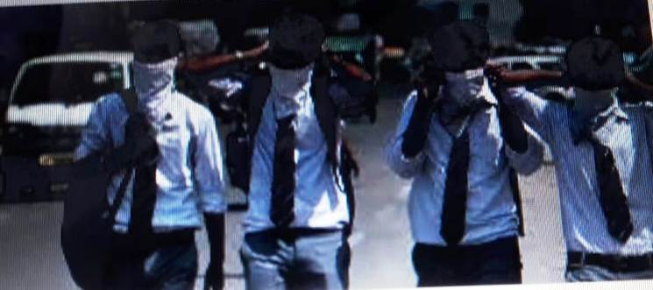 The quality of air at various locations is monitored regularly by Government and other agencies. The best indicator that is used for assessing health impacts that result from air pollution is PM 2.5. A PM 2.5 value of 35 or more is considered hazardous to health.

As per 2018 version of WHO data base Kanpur is the most polluted city in the country having PM2.5 value 173.Out of top 10 polluted cities in the world 7 cities are in India.

**CONCLUSION:**

We can’t stop breathing, but we can do something about the quality of air that we breathe.

Small contributions on our part can make a huge difference in the state of the environment. We can plant trees and nurture the ones already present in our neighborhood. **VAN MAHOTSAV** when lakhs of trees are planted in July every year.

China with its growing green energy sector has emerged as a climate leader. The country owns half the world’s electric vehicles and 99percent of the world’s electric buses.

**Say no to crackers** campaign made a big difference to the air pollution levels around Diwali. There is need to switch over to alternative source of energy instead of fossil fuels for our energy requirements. These could be **SOLAR, HYDROPOWER AND WIND ENERGY.**

**BE A PART OF THE SOLUTION NOT PART OF THE POLLUTION**

**REFERENCES:**

1. Environmental Science---W. P. Cunningham
2. UN Environment News & Media
3. Managing Industrial Pollution----S. C. Bhatia
4. Climate Change-----John Adams
5. Global Warming------Amanda Mac Milan
6. Global Warming-----Wikipedia
7. Climate & Clean Air---BEMNET ALEMAYEHU

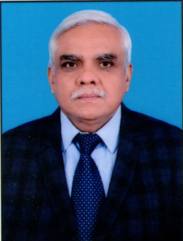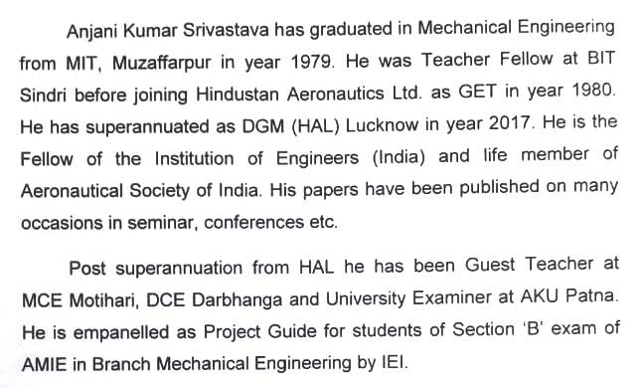**About the Author**

.

**\*\*\*\*\*\*\***

**AIR POLLUTION**

**Prof:- S.K. Chaudhary**

**M.I.T., Muzaffarpur**

Air pollution refers to the release of pollutants (like- Smog, soot, pollen, mold and green hours gores) into the environmental air that are detrimental effect to human health and the planet ( earth) as a whole.

The clean air act authors the U.S Environmental Protection Agency (EPA) to protect public health by regulating the emission to these harmful air pollutants. The NPDC has been a leading authority on this law since it was established in 1970.

What causes AIR Pollution:-

Air pollution is causes by the presence in the atmosphere of toxic substances, mainly produced by human activities, even though some times it can be result from natural phenomena such as volcanic eruption, dust storms and wild fires, also depleting the air quality Anthropogenic air pollution sours are :-

* Combustion of fossil fuel, like coal or oil for electricity and road transport producing air pollutants like nitrogen and Sulphur di-oxide.
* Emission from industries and factories, relearning large amount of carbon monoxide, hydrocarbon, chemicals only organic compounds into the air.
* Agricultural activities, due to the use of pesticides, west-sides and fertilizers that emits harmful chemicals.
* Waste productions, mostly because of methane generation in Landfills.
* Damp conditions causes by extreme weather and flooding.
* Pollen due to a longer pollen season and more pollen production.

Effects of Air pollution: -

The sours of smog and soot are similar both come from vehicles, production factories, power plants, incinerators, engineer-anything that combust fossil fuel such as coal, gas or natural gases.

Smog or “ground level ozone” as it is occur when emissions from combusting fossil fuels reacts with direct sunlight, smog can irritate the eyes and throat also damage the lunge – especially of people who work or exercise outside. It is even works for people who have asthma or allergies. There higher amount in pollinations not only intensify their symptoms but also trigger asthma attack.

SOOT:- it is a particulate matter is made up of tiny partially of chemicals, soil, smoke, dust or allergens in term of gas or solids that are carried in the air. The finniest airborne. Particle in the soot whether they are in the form of gas or solids are especially dangerous because can penetrate into the lungs and bloodstream and wore bronchitis and lead to heart attack.

There are most hazardous air pollutants like mercury, lead, dioxins and benzene. There are also most often emitted during gas or coal combustion, incinerating or in case of benzene, found in gasoline.

Benzene classified as a carcinogen by EPA can cause, eye skin and lung irritation in the short term and blood disorder in the long term.

Dioxin: - More typically found in food but also present in small amount in the air can affect the lever in the short term and harm the immune, nervous and endocrine system as well as reproductive function leads in large amount can damage children’s brain and kidney’s and even in small amount it can effect children I and ability to learn.

Mercury It effects the central nervous system of the body. In small amount it can effect children and ability to learn Mercury. It affects control nervous system.

1. Traffic exhaust and wildfire smoke :- Polycyclic are mate Lydrohan are toxic components. It large amount it have been likes to eye and lung irritation, blood and liver issues and even cancer.

Pollen and Mold:- Mold and allergens from trees weed and grass as also carried in the air as exact blow by climate by climate change, and can be hazardous to health. There are not regulated by the Government and ok less directly connected to human serrations it can be candies air pollution. (When harmer, school or baronesses get Cooter damage, mold can grow and can produce allergenic air be pollutants. Mold exposer can recitation asthma effects or an alleger response. And some, molds can even produce toxin that would be dangerous for anyone to inhale.

Pollen- pollen allergic as worsens because of almost change. More Co2 pollen producing plant- especially weed an grown in climate change also extends the pollen producing reason. That means more people will suffer. Zumaya Norse integers itchy eye and other emptions.

1. How to help reduce air pollution?

The solar impulse label is granted to innovative solutions to air pollution that much high standards of sustainability and profitability. The less girl limb we burn.

* Make good character about transportation.
* For diver Choo case that get biter mile per city. To gas chooks an election ear.
* By your power proved options. Electricity be supplied by wind and boar.
* Buying your food locally.
* Cut down on the fossil fuels bird new in transportation.
* Support leaders who push for clean air and water and impossible steps on climate change.

(B) How to protect your health:-

If pollutions level in are high, it may be useful to limit the time. When children or you go outside for a john Generally, ozone. Levels tend to below in the morning.

* If air quality is bad stay inside with window closer.
* Wear sunscreen when arteriole readies comes together the weakened ozone layer. It can cause. Sun dangers.

Air pollution solutions:-

The solar mumbles label is grandee to innovation. Solutions to oat pollution that much high standards of just air ability and profitability.

*******

**Air Pollution and India: Current Scenario**

Er. Lok Ranjan, AMIE

Lecturer, Deptt. Of Mech. Engg.,

Govt. Polytechnic, Vaishali

**Abstract:**

The capital city of India, New Delhi has been recognized as the most polluted city in the world. World Health Organization (WHO) has reported this as per their findings in 2018. It is indeed an alarming issue for the health of our future generations in India. We are aware of the ill effects of environmental pollutants and toxicants on health status of human as well as other living organisms and environment. The most affected to the toxic effect are children and old people. Some significant measures should be taken and some strict laws should be made to prevent environmental pollutions in the major cities of India. Deadly diseases like cancer and asthma etc. are increasing in Indian population. Pollution is indeed responsible for such increasing incidences of diseases.

Key words: Pollutants, Toxicants, Health Status, Environment, Diseases.

**Introduction:**

It is shocking to know that out of the top twenty most polluted cities in the world, thirteen are in India (https://agenda.weforum.org/2015/06/which-is most-polluted-city). Allahabad, Agra, Lucknow, Kanpur, Amritsar etc. are among the list of top 20 most polluted cities in the world (https://agenda.weforum.org/2015/06/which the-worlds-most-polluted-city/). Other major cities of neighboring countries of India i.e. Karachi, Rawalpindi and Peshawar in Pakistan, Beijing in China are also in the list (https://agenda.weforum.org/2015/06/whichmost-polluted-city/). Pollution is a real threat to health and well-being of mankind. Studies by WHO reveal that globally seven million people died because of exposure of air pollution. Those include death due to exposure to toxic pollutants both inside house and in the environment (http gov/health/topics/agents/air-pollution/).

**Major Air Pollutants:**

The major sources of air pollution in India and around the globe are automobile exhaust and industrial emissions (http://www.niehs.nih.gov/health/topics/agents/air The prime air pollutants have been broadly classified as outdoor and indoor pollutants (Fig.1). Outdoor pollutants include remains of fossil fuel, carbon particles and metallic particles in the atmosphere from industrial and automobile emissions, toxic gases i.e., nitrogen dioxide, carbon monoxide, sulfur dioxide etc. and ozone, tobacco smoke etc. On the other hand indoor pollutants include toxic gases produced from kitchen fuels, building materials i.e., asbestos, lead etc. tobacco smoke etc. (http://www.niehs.nih.gov/health/topics/agents/air pollution). Delhi has been found to have the highest concentration of “Respiratory S (RSPM) in the air. The concentration of RSPM in the air of Delhi is highest than that found in the air of the other metro cities of India.

**The Most Polluted City In The World Is In India!**

New Delhi is a busy metropolitan city, the capital of India. In May 2014, Particle Matter (PM) of size less than 2.5 micrometers in diameter measured concentrations was found to be greater than 350 micrograms per cubic meter of air in the city of New Delhi, making the city the most polluted city in the world as per WHO (http://www.theguardian.com/news/datablog/2015/jun/24/air-pollution-delhi-is-dirty-but-how-doother-cities-fare). This enhanced concentration of PM of various sizes in atmosphere is due to increasing automobile exhaust and increase of coal fueled factories in the cities. According to WHO report, Delhi is the worst polluted city in the world and the major source of the particulate matter i.e. solid and liquid particles of diameter less than 2.5 micro meter are the smoke coming out from industries in the city (https://agenda.weforum.org /2015/06/which-is-the-worldsmost-polluted-city/; http://www.theguardian.com/news /datablog/2015/jun/24/air-pollution-delhi-is-dirty-but-how-doother-cities-fare; http://time.com/ 3608534/india-new-delhiworlds-most-polluted-city/).

**Physiological Disorders and Air Pollution A Workshop on ‘Burden of Disease:**

Air Pollution among top killers’ was organized at New Delhi on February 13, 2013 by the Centre for Science and Environment (CSE) in collaboration with the Indian Council of Medical Research, New Delhi and Health Effects Institute, Boston US. Their report showed that air pollution is one among the top ten killers in the world (http://www.cseindia.org/content/workshop-global-burdendisease-air-pollution-amongst-top-killers-india). Air pollution is the 6th most deadly killer in South East Asia and has been recognized as the 5th largest killer in India (http://time.com/3608534/india-new-delhi-worlds-mostpolluted-city/). Hypertension and associated risk of cardiovascular disorder has been found to be linked with exposure to polluted air (Debasish Bandyopadhyay et al., 2014; http://www.medicinenet.com/script/main/art.asp? article key=105529). Particles less than 2.5 micrometer in diameter are small enough to enter into respiratory system and cause fatal physiological consequences (http://www.ibtimes.co.uk/world-environment-day-10-mostpolluted-cities-world-1504260). Particles of this small size originate from dirt and dust on road, grinded by vehicles6. Those small sized particulate matters are the most harmful ones. Because of their small size they can easily enter circulation and reach tissues. Air pollutions leads to various types of pathological conditions including pulmonary carcinoma, COPD and skin problems as well. Disorders like bronchitis, respiratory distress, dermatitis etc. are very common with exposure to toxic environmental pollutants (<https://agenda.weforum.org/2015/06/which-is-theworlds-most-polluted-city/>).

According to WHO more than 80% death occurs due to pollution induced ischemic heart disease (http://urbanemissions.blogspot.in/2014/01/delhi-ranks-1stamong-world-cities-with.html). Pregnancy complications may also arise due to regular exposure to toxic environmental pollutants. Particulate matter of small size in respiratory air has been found to be responsible for hypertension in individuals (http://www.cseindia.org/content/workshop-global-burdendisease-air-pollution-amongst-top-killers-india). Delhi has been recognized as the “asthma capital” of India (http://www.medicinenet.com/script/main/art.asp?articlekey=1 05529). Studies by WHO reveal that the professionals like traffic cops are at high risk of respiratory disorders due to their unavoidable and regular exposure to pollutants (http://timesofindia.indiatimes.com/city/nagpur/Traffic-copsfalling-prey-to-lung-diseases/articleshow/47620826.cms). Oxidative stress and pollution induced oxidative stress mediated disorders has also been found to be more in those traffic cops ([http://timesofindia.indiatimes.com/city/nagpur/Traffic-cops-falling-prey-to-lung-diseases/articleshow/ 47620826.cms](http://timesofindia.indiatimes.com/city/nagpur/Traffic-cops-falling-prey-to-lung-diseases/articleshow/%2047620826.cms)).

Most Vulnerable Ones Professionals like traffic cops, hawkers are regularly exposed to air pollutants. Besides, people who have to travel regularly for professional requirement in metropolitan cities are also exposed to air pollutants. Shopkeepers of shops located at large crossings and road side of large cities are as well exposed to air pollutants. Hawkers and drivers of public transport vehicles i.e., bus, auto, taxi, rickshaw etc., are also vulnerable to the consequences of air pollution. Residents of houses located at busy roads are regularly exposed to air contaminants and suffer the consequences (http://timesofindia.indiatimes.com/city/ nagpur/Traffic-cops-falling-prey-to-lung-diseases/article show /47620826.cms).

**Conclusion:**

Government of India has already taken several measures to prevent and control air pollution in the country. Further, the government needs to enact laws for prevention of this increasing air pollution and emission standard of air pollutants. Already more than 15 years old vehicles have been banned from running on the roads of Delhi by Government (http://urbanemissions.blogspot.in/2014/01/delhi-ranks-1stamong-world-cities-with.html). Steps have also been taken for reducing vehicles using diesel as fuel on roads of Delhi (http://www.theguardian.com/news/datablog/2015/jun/24/airpollution-delhi-is-dirty-but-how-do-other-cities-fare). Electrostatic precipitators have been added to chimneys of industries to prevent emission of particulate matters in the environment. We should also seriously consider alternative energy and renewable energy use to reduce pollution. Using respiratory mask should be encouraged among traffic cops and others who get regularly exposed to toxic air contaminants.

**References:**

1. Debosree Ghosh, Pratap Parida. Lead Poisoning and California Condor. Journal of New Science Biotechnology, 1(1): 7-9. 2015.

2. Debasish Bandyopadhyay, Debosree Ghosh, Aindrila Chattopadhyay. Lead Induced Oxidative Stress Mediated Myocardial Injury: A Review. Int. J. Pharm. Sci. Rev. Res., 29(2), November – December 2014; Article No. 13, Pages: 67-71.

3.<http://urbanemissions.blogspot.in/2014/01/delhi-ranks-1stamong->world-cities-with.html <http://www.cseindia.org/content/workshop-global-burdendisease-air-pollution-amongst-top-killers-india>.

4.http://www.niehs.nih.gov/health/topics/agents/air-pollution.

*********

*AIR POLLUTION*

Prabhat Ranjan Bhardwaj, AMIE

Lecturer, Deptt. Of Mech. Engg.,

Govt. Polytechnic, Vaishali

Introduction

Air pollution consists of chemicals or particles in the air that can harm the health of humans, animals, and plants. It also damages buildings. Pollutants in the air take many forms. They can be gases, solid particles, or liquid droplets.  
  
Sources of Air Pollution  
  
Pollution enters the Earth's atmosphere in many different ways. Most air pollution is created by people, taking the form of emissions from factories, cars, planes, or aerosol cans. Second-hand cigarette smoke is also considered air pollution. These man-made sources of pollution are called anthropogenic sources.  
  
Some types of air pollution, such as smoke from wildfires or ash from volcanoes, occur naturally. These are called natural sources.  
  
Air pollution is most common in large cities where emissions from many different sources are concentrated. Sometimes, mountains or tall buildings prevent air pollution from spreading out. This air pollution often appears as a cloud making the air murky. It is called smog. The word "smog" comes from combining the words "smoke" and "fog."   
  
Large cities in poor and developing nations tend to have more air pollution than cities in developed nations. According to the World Health Organization (WHO), some of the worlds most polluted cities are Karachi, Pakistan; New Delhi, India; Beijing, China; Lima, Peru; and Cairo, Egypt. However, many developed nations also have air pollution problems. Los Angeles, California, is nicknamed Smog City.   
  
Indoor Air Pollution  
  
Air pollution is usually thought of as smoke from large factories or exhaustfrom vehicles. But there are many types of indoor air pollution as well.   
  
Heating a house by burning substances such as kerosene, wood, and coal can contaminate the air inside the house. Ash and smoke make breathing difficult, and they can stick to walls, food, and clothing.  
  
Naturally-occurring radon gas, a cancer-causing material, can also build up in homes. Radon is released through the surface of the Earth. Inexpensive systems installed by professionals can reduce radon levels.  
  
Some construction materials, including insulation, are also dangerous to people's health. In addition, ventilation, or air movement, in homes and rooms can lead to the spread of toxic mold. A single colony of mold may exist in a damp, cool place in a house, such as between walls. The mold's spores enter the air and spread throughout the house. People can become sick from breathing in the spores.  
  
Effects On Humans  
  
People experience a wide range of health effects from being exposed to air pollution. Effects can be broken down into short-term effects and long-term effects.   
  
Short-term effects, which are temporary, include illnesses such as pneumoniaor bronchitis. They also include discomfort such as irritation to the nose, throat, eyes, or skin. Air pollution can also cause headaches, dizziness, and nausea. Bad smells made by factories, garbage, or sewer systems are considered air pollution, too. These odors are less serious but still unpleasant.  
  
Long-term effects of air pollution can last for years or for an entire lifetime. They can even lead to a person's death. Long-term health effects from air pollution include heart disease, lung cancer, and respiratory diseases such as emphysema. Air pollution can also cause long-term damage to people's nerves, brain, kidneys, liver, and other organs. Some scientists suspect air pollutants cause birth defects. Nearly 2.5 million people die worldwide each year from the effects of outdoor or indoor air pollution.   
  
People react differently to different types of air pollution. Young children and older adults, whose immune systems tend to be weaker, are often more sensitive to pollution. Conditions such as asthma, heart disease, and lung disease can be made worse by exposure to air pollution. The length of exposure and amount and type of pollutants are also factors.

Effects On The Environment  
  
Like people, animals, and plants, entire ecosystems can suffer effects from air pollution. Haze, like smog, is a visible type of air pollution that obscures shapes and colors. Hazy air pollution can even muffle sounds.   
  
Air pollution particles eventually fall back to Earth. Air pollution can directly contaminate the surface of bodies of water and soil. This can kill crops or reduce their yield. It can kill young trees and other plants.   
  
Sulfur dioxide and nitrogen oxide particles in the air, can create acid rainwhen they mix with water and oxygen in the atmosphere. These air pollutants come mostly from coal-fired power plants and motor vehicles. When acid rain falls to Earth, it damages plants by changing soil composition; degrades water quality in rivers, lakes and streams; damages crops; and can cause buildings and monuments to decay.   
  
Like humans, animals can suffer health effects from exposure to air pollution. Birth defects, diseases, and lower reproductive rates have all been attributed to air pollution.   
  
Global Warming  
  
Global warming is an environmental phenomenon caused by natural and anthropogenic air pollution. It refers to rising air and ocean temperatures around the world. This temperature rise is at least partially caused by an increase in the amount of greenhouse gases in the atmosphere. Greenhouse gases trap heat energy in the Earth’s atmosphere. (Usually, more of Earths heat escapes into space.)  
  
Carbon dioxide is a greenhouse gas that has had the biggest effect on global warming. Carbon dioxide is emitted into the atmosphere by burning fossil fuels (coal, gasoline, and natural gas). Humans have come to rely on fossil fuels to power cars and planes, heat homes, and run factories. Doing these things pollutes the air with carbon dioxide.  
  
Other greenhouse gases emitted by natural and artificial sources also include methane, nitrous oxide, and fluorinated gases. Methane is a major emission from coal plants and agricultural processes. Nitrous oxide is a common emission from industrial factories, agriculture, and the burning of fossil fuels in cars. Fluorinated gases, such as hydro fluorocarbons, are emitted by industry. Fluorinated gases are often used instead of gases such as chlorofluorocarbons (CFCs). CFCs have been outlawed in many places because they deplete the ozone layer.  
  
Worldwide, many countries have taken steps to reduce or limit greenhouse gas emissions to combat global warming. The Kyoto Protocol, first adopted in Kyoto, Japan, in 1997, is an agreement between 183 countries that they will work to reduce their carbon dioxide emissions. The United States has not signed that treaty.   
  
Regulation  
  
In addition to the international Kyoto Protocol, most developed nations have adopted laws to regulate emissions and reduce air pollution. In the United States, debate is under way about a system called cap and trade to limit emissions. This system would cap, or place a limit, on the amount of pollution a company is allowed. Companies that exceeded their cap would have to pay. Companies that polluted less than their cap could trade or sell their remaining pollution allowance to other companies. Cap and trade would essentially pay companies to limit pollution.   
  
In 2006 the World Health Organization issued new Air Quality Guidelines. The WHOs guidelines are tougher than most individual countries existing guidelines. The WHO guidelines aim to reduce air pollution-related deaths by 15 percent a year.  
  
Reduction  
  
Anybody can take steps to reduce air pollution. Millions of people every day make simple changes in their lives to do this. Taking public transportation instead of driving a car, or riding a bike instead of traveling in carbon dioxide-emitting vehicles are a couple of ways to reduce air pollution. Avoiding aerosol cans, recycling yard trimmings instead of burning them, and not smoking cigarettes are others.

Reference

1. J. Duffie, W. Beckman, Solar engineering of thermal processes,3rd edn. (Wiley, New York, 2006)

2. A.K. Yadav, S.S. Chandel, Tilt angle optimization to maximize incident solar radiation: a review. Renew. Sustain. Energy Rev. 23, 503–513 (2013)

3. N.K.M. Yazdanpanah, Z. Namjouyan, Green or in between? Examining youth perceptions of renewable energy in Iran.Energy Res. Soc. Sci. 8, 78–85 (2015)

4. D.K. Singh, N.K. Swarnkar, M. Lalwani, A review on growth and future plans of solar power generation in India. Int. J. Adv. Eng. Res. Sci. 2, 7–10 (2015)

5. C.W. Shoulders, J.D. Wyatt, D.M. Johnson, Demonstrations and lectures about solar energy in Arkansas: the importance of experiential learning. Energy Res. Soc. Sci. 4, 100–105 (2014)

**\*\*\*\*\*\*\*\*\***

***AIR POLLUTION***

Er. Rahul Kumar, AMIE

Lecturer, Deptt. Of Mech. Engg.

Govt. Polytechnic, Vaishali

**AIR POLLUTANT:-**

Air pollutant is any substance in the atmosphere is likely to cause harm to human ,plant, animal life, damage to manmade materials &substance, change in weather or climate, interface with enjoyment of life or property.

**Major air pollutants: -**

Suspended particulate matter, sulphur dioxide (So2) , nitrogen dioxide (No2)

Carbon monoxide (Co), ozone, lead, greenhouse gases.

**AIR POLLUTION: -**

When an amount of air pollutant in the atmosphere is enough to cause adverse effects to human health and the environment.

It is a form of visible or invisible particle or gas found in the air.

**CLASSIFICATION: -**

1). **NATURAL 2). MAN-MADE**

**Natural: -** pollen grains, spores, dust storms, forest fire, bacteria&other organisms.

**Man-made:-** industrial units, thermal power plants, automobile exhausts, fossil fuel, burning, mining, nuclear explosions.

A pollutant can be solid, liquid or gas.

When air pollution in urban and industrial areas is often is called smog.

The mixture of gases and particle is produced in strong sunlight then it produces photochemical smog.

The major component of photochemical smog is ozone.

**Major sources:-**

Industrial units, thermal power plants, automobile exhausts, fossil fuel, burning, mining, nuclear explosions, chemical reaction, construction equipment’s etc.

**EFFECTS:-**

Reduce oxygen, decreases in vision, causes headache, lungs problems, marbles, cloths, paper, plant damage etc.

**CONTROLLING:-**

Proper selection of suitable fuel, construction equipment’s& industrial units, to less toxic form,& modification in industrial process, by using pollution controlling equipment’s, by obey government rules act.

**REFERENCE:**

1.N.K.M. Yazdanpanah, Z. Namjouyan, Green or in between? Examining youth perceptions of renewable energy in Iran.Energy Res. Soc. Sci. 8, 78–85 (2015)

2. D.K. Singh, N.K. Swarnkar, M. Lalwani, A review on growth and future plans of solar power generation in India. Int. J. Adv. Eng. Res. Sci. 2, 7–10 (2015)

3. C.W. Shoulders, J.D. Wyatt, D.M. Johnson, Demonstrations and lectures about solar energy in Arkansas: the importance of experiential learning. Energy Res. Soc. Sci. 4, 100–105 (2014)

*********

**AIR POLLUTION**

**Er. Krishan Kanhai,AMIE**

**Lecturer, Deptt. Of Electrical Engg.**

**Govt. Polytechnic, Vaishali**

**Introduction;**

**Air** lets our living planet breathe—it's the mixture of gases that fills the atmosphere, giving life to the plants and animals that make Earth such a vibrant place. Broadly speaking, air is almost entirely made up of two gases (78 percent nitrogen and 21 percent oxygen), with a few other gases (such as carbon dioxide and argon) present in absolutely minute quantities. We can breathe ordinary air all day long with no ill effects, so let's use that simple fact to define air pollution, something like this:

Air pollution is a gas (or a liquid or solid dispersed through ordinary air) released in a big enough quantity to harm the health of people or other animals, kill plants or stop them growing properly, damage or disrupt some other aspect of the environment (such as making buildings crumble), or cause some other kind of nuisance (reduced visibility, perhaps, or an unpleasant odor)

As with [water pollution](https://www.explainthatstuff.com/waterpollution.html) and [land contamination](https://www.explainthatstuff.com/land-pollution.html), it's the quantity (or concentration) of a chemical in the air that makes the difference between "harmless" and "pollution." Carbon dioxide (CO2), for example, is present in the air around you at a typical concentration of less than 0.05 percent and breathing it in usually does no harm (you breathe it out all day long); but air with an extremely high concentration of carbon dioxide (say, 5–10 percent) is toxic and could kill you in a matter of minutes. Since Earth's atmosphere is very turbulent—many of us live in windy countries—air pollution will often disperse relatively quickly. In less enlightened times, factory operators thought that if they built really high smokestacks, the wind would simply blow their smoke away, diluting and dispersing it so it wouldn't be a problem. The only trouble was, Earth is a much smaller place than we think and pollution doesn't always disappear so conveniently.

Natural air pollution

When we think of pollution, we tend to think it's a problem that humans cause through ignorance or stupidity—and that's certainly true, *some* of the time. However, it's important to remember that some kinds of air pollution are produced naturally. Forest fires, erupting volcanoes, and gases released from [radioactive decay](https://www.explainthatstuff.com/how-geiger-counters-work.html) of rocks inside Earth are just three examples of natural air pollution that can have hugely disruptive effects on people and the planet.

Forest fires (which often start naturally) can produce huge swathes of smoke that drift for miles over neighboring cities, countries, or continents. Giant volcanic eruptions can spew so much dust into the atmosphere that they block out significant amounts of sunlight and cause the entire planet to cool down for a year or more. Radioactive rocks can release a gas called [radon](https://www.epa.gov/radon) when they decay, which can build up in the basements of buildings with serious effects on people's health (each year, around [21,000 people die](https://www.epa.gov/radon/health-risk-radon) of lung cancer, due to radon gas in the United States).

All these things are examples of serious air pollution that happen without any help from humans; although we can adapt to natural air pollution, and try to reduce the disruption it causes, we can never stop it happening completely. For the rest of this article, we'll consider only the "unnatural" types of pollution: the problems that people cause—and the ones we can solve.

**the causes of air pollution**

Anything people do that involves burning things (combustion), using household or industrial chemicals (substances that cause chemical reactions and may release toxic gases in the process), or producing large amounts of dust has the potential to cause air pollution. Step back a century or two and the cause of most air pollution was easy to identify: filthy factories, powering the Industrial Revolution. Today, tighter air pollution laws, greater [environmental awareness](https://www.explainthatstuff.com/introduction-to-environmentalism.html), and determined campaigns mounted by local communities make it far harder—though by no means impossible—for factories to pollute in post-industrial nations.

Where, then, does modern air pollution come from? By far the biggest culprit today is traffic, though power plants and factories continue to make an important contribution. Before we start laying the blame for air pollution, let's remember one very important thing: most of us drive (or travel in) cars, use [electricity](https://www.explainthatstuff.com/electricity.html), and buy goods made in factories. Although traffic, power plants, and industrial and chemical plants produce the majority of Earth's manmade air pollution, many other factors contribute to the problem. In some parts of the world, people still rely on burning woodfuel for their cooking and heating, and that produces indoor air pollution that can seriously harm their health ([solar cookers](https://www.explainthatstuff.com/solar-cookers.html) are one solution to that problem). In some areas, garbage is incinerated instead of being [recycled](https://www.explainthatstuff.com/recycling.html) or landfilled and that can also produce significant air pollution unless the incinerators are properly designed to operate at a high enough temperature.

How can we solve the problem of air pollution?

As we discovered in the last section, air pollution means different problems at different scales—in other words, it's not one single problem but many different ones. Solving a problem like passive smoking (how one person's cigarette smoke can harm other people's health) is very different to tackling a problem like global warming, though both involve air pollution and they do have some things in common (both problems, for example, require us to think about how our behavior can affect other people in the short and long term and to act more considerately). Generally, air pollution is tackled by a mixture of technological solutions, laws and regulations, and changes in people's behavior.For example, it's easier for car makers to keep on making [gasoline engines](https://www.explainthatstuff.com/carengines.html) than to develop [electric cars](https://www.explainthatstuff.com/electriccars.html) or ones powered by [fuel cells](https://www.explainthatstuff.com/fuelcells.html) that produce less pollution. The world has thousands of coal-fired power plants and hundreds of [nuclear power stations](https://www.explainthatstuff.com/how-nuclear-power-plants-work.html) and, again, it's easier to keep those going than to create an entirely new power system based on [solar panels](https://www.explainthatstuff.com/solarcells.html), [wind turbines](https://www.explainthatstuff.com/windturbines.html), and other forms of [renewable energy](https://www.explainthatstuff.com/renewableenergy.html) (though that is happening slowly).

**Control of Air Pollution:**

1. Industrial estates should be established at a distance from residential areas.

2. Use of tall chimneys shall reduce the air pollution in the surroundings and compulsory use of filters and electrostatic precipitators in the chimneys.

3. Removal of poisonous gases by passing the fumes through water tower scrubber or spray collector.

4. Use of high temperature incinerators for reduction in particulate ash production.

5. Development and employment of non-combustive sources of energy, e.g., nuclear power, geothermal power, solar power, tidal power, wind power, etc.

6. Use of non-lead antiknock agents in gasoline.

Air pollution currently affects the health of millions of people. We have presented evidence on the effects of pollutants on patients with limitations in their respiratory capacities. For example, O3 and PM may trigger asthma symptoms or lead to premature death, particularly in elderly individuals with pre-existing respiratory or cardiovascular disease. In addition, pollutants enhance the release of allergenic pollen grains, which results in an increased prevalence of pollen-induced asthma. Thus, the case for action to reduce air pollution is overwhelming and this action can take many forms. Some of these include urban planning, technological developments (e.g. the design of new vehicles that produce less pollution), and at the government level, the introduction of new laws. It has been estimated that reducing both black carbon and O3 levels would prevent over 3 million premature deaths and increase crop yields by around 50 million tonnes annually. Improvements to cooking stoves would also decrease demand for firewood and reduce deforestation in the developing world. Similarly, improved brick kilns that are used in parts of Latin America and Asia use 50% of the fuel used by traditional kilns.[81](https://www.ncbi.nlm.nih.gov/pmc/articles/PMC3532603/#b81)

If air pollution levels in heavy traffic areas were reduced, the incidence of asthma and other respiratory diseases would be significantly reduced.[28](https://www.ncbi.nlm.nih.gov/pmc/articles/PMC3532603/#b28) While it is generally accepted that efforts to reduce air pollution will prevent further environmental changes, they will not reverse existing warming. Interestingly, an increasing number of studies show that in individuals with low anti-oxidant levels, dietary supplements could be used as a promising approach to reducing susceptibility to air pollution, and providing an alternative strategy for neutralizing the effects of pollutants on health.

Reference:

1.J.E. Carlisle, S.L. Kane, D. Solan, J.C. Joe, Support for solar energy: examining sense of place and utility-scale development in California. Energy Res. Soc. Sci. 3, 124–130 (2014).

2. K. Bakirci, Models of solar radiation with hours of bright sunshine: a review. Renew. Sustain. Energy Rev. 13, 2580–2588 (2009)

3.The Wikipedia website. [Online]. Available: http://en.wikipedia.org/wiki/Electricity_sector_in_India .

4.The BEE website. [Online]. Available: <http://beeindia.in/>

********

**AIR POLLUTION**

**Suyasta Kumari,**

**Deptt. Of Civil Engg.**

**PSTC Bhagwanpur, Vaishali**

**Let us understand first ‘What is Pollution’?**

Pollution is derived from a latin word ‘pollure’ which means defile. It is undesirable change in the physical, chemical or biological characteristics of our air, land and water that can harmfully affect human life or that of other species.

* Meaning of air pollution: Air pollution defined as imbalance in the quality of air so as to cause ill effects. The different types of pollutants are continuously introduced into the atmosphere and are removed by natural process of cleaning. It is among the critical challenges facing modern societies and is one of the most pressing environing mental problems. Air pollution is accountable for major harmful effects on human strength, animal survives, natural ecosystems and man-made environment. It is also responsible for climate change due to the improved greenhouse effect, acid rain, and the reduction of the ozone layer that inaugurate important global environmental problems. It occurs both outdoors and indoors and is caused by human activities and natural mechanisms.

All living things use air and it must be clean to maintain life on earth. So its high time to say loudly “NO” to air pollution.

Main reasons for increasing rate of our pollution:-

1. Increased use of chemicals and petro-chemicals.
2. Fast rate of deforestation.
3. Space research and satellite wastes.
4. Poisonous gases and other particles emitted from industries without any treatment.
5. Natural events such as volcanic eruption, dust storms etc.
6. Combustion of fossil fuels, likecoal and oil for electricity and road transport, producing air pollutants like nitrogen and sulphur dioxide.
7. Agricultural activities, due to the pesticides, insecticides, and fertilizers that emit harmful chemicals.

Major impact of air pollution are:-

**A. On the environment**

Air pollution has a major impact on the process of plant evolution by preventing photosynthesis in many cases, with serious consequences for the purification of the air we breathe. It also contributes to the formation of acid rain, atmospheric precipitations in the form of rain, frost, snow, or fog, which are released during the combustion of fossil fuels and transformed by contact with water steam in the atmosphere.

**B. GLOBAL WARMING**

Air pollution is a major contributor to global warming and climate change. In fact the abundance of carbon dioxide in the air is one of the causes of the greenhouse effect. Normally, the presence of greenhouse gases should be beneficial for the planet because they absorb the infra-red radiation produced by the surface of the earth. But the excessive concentration of these gases in the atmosphere is the cause of the recent climate change. The Ozone layer considered crucial for the existence of the ecosystems on the planet is depleting due to increased pollution. Global warming, a direct result of the increased imbalance of gases in the atmosphere has come to be known as the biggest threat and challenge that the contemporary world has to overcome in a bid for survival.

**C. On Human Health**

Our continual exposure to air pollutants is responsible for the deterioration of human health.

Air pollution is indeed a significant risk factor for human health conditions, causing allergies, respiratory and cardiovascular diseases as well as lung damage.

“Now a question arise that our forefathers have given many trees, what we will give to our future generation?”

For our future generation we have to take some preventions to reduce air pollution.

**1. Renewable fuel and clean energy production**.

The most basic solution for air pollution is to move away from fossil fuels, replacing them with alternative energies like solar, with and geothermal.

**2. Energy conservation and efficiency**.

Production clean energy is crucial. But equally important is to reduce our consumption of energy by adopting responsible habits and using more efficient devices.

**3. Eco-friendly transportation.**

Shifting to electric vehicles and hydrogen vehicles, and promoting shared mobility [i.e. carpooling, and public transports] could reduce air pollution.

**4. Green building**.

From planning to demolition, green building aims to create environmentally responsible and resource-efficient structures to reduce their carbon footprint.

5. The government also takes some steps to control air pollution.

1. The Air [Prevention and Control of Pollution] Act, 1981 an Act of the parliament of India to control and prevent air pollution in India.
2. The govt. in Delhi launched an Odd-Even Rule in November, 2017 which is based on Odd-Even rationing method.
3. The Indian government has committed to a 50% reduction in households using solid fuel for cooking.

**Now it’s our duty to “Spread Solution Not Pollution**”.

So much is being done to control, monitor and rectify damage done by pollutants. The problems are diverse and some are only being recognised but it is important to keep a close control over pollutants so that we can maintain the environment in an acceptable condition for future generations. We should always remember that pollution problems affect us all so each of us has to do his or her best to help restore ecological balance to this beautiful place we call home. Learn about the major polluters in your area to protect the air and water where you live.

Don’t inhale toxic air, it will makes your lungs dustbin.

Encourage people to stop pollution, tell them everything you know about this problem, and protest together to prevent the worst from happening.

“Let’s protect the water we drink, the air we breathe, and the soil we use to grow our food.”

**\*\*\*\*\*\*\*\***

AIR POLLUTION

Diksha Kumari

Deptt. Of Civil Engg.

PSTC Bhagwanpur, Vaishali

INTRODUCTION:-

* Air is one of the most important constituents of our environment.
* An average human beings requires about 12 kg of air each day, which is nearly 12 to 15 times greater than the amount of food consumed.
* Eventually, even a small concentration of pollutants present in the air becomes more harmful to human health, in comparison to similar concentrations pollutants present in food.
* Air pollution occur when harmful or excessive quantity of substances including gases, particles and biological molecules are introduce into earth atmosphere.
* Air pollution is the mixture of natural and man-made substances in the air we breathe.
* Air pollution is, therefore, defined as the presence of any solid, liquid, or gaseous substance (including noise) present in the atmosphere in such concentrations that may or tends to be injurious to human beings, or other living creatures or plants, or property.
* The solid liquid or gaseous substance, which when present in air, cause in harmful effect on the abiotic and biotic component in our environment, eventually called the air pollutant

NATURAL AND MAN-MADE AIR POLLUTION:-

* Mainly two source of air pollution 1st one is ‘’natural air pollution’’ and 2nd one is ‘’men-made air pollution’’, naturally occurring events, like VOLCANOES -which releases huge amounts of ash, dust, Sulphur, and other gases into the air atmosphere. The air pollution may be caused by human activity, such as burning of fossil fuels, intentional burning of forests to clear land for urbanization or agriculture etc.
* The air pollution caused by the natural hazardous events tend to remains in the atmosphere for a short time. But the air pollution released by human activities may continue to stay in the air environment for long periods and may even load to permanent atmospheric changes.

CAUSES

* The air pollution on earth originated when the man started using firewood for cooking and heating purposes.
* Air pollution assumed gigantic proportions in ‘’London smog’’ occurred in December 1952, which caused the death of about 4000 people due to accumulation of air pollutants over the London city for five consecutive days.
* Air pollution further began to increases in the beginning of the 20th century with the development of transportation systems, and large scale use of petrol and diesel in automobiles. The use of coal and diesel for running trains, use of petrol and diesel fir auto vehicles, and use of aviation fuel for running airplanes.
* Air pollution caused by emission of smokes from factories, coke ovens, furnaces, steam engines, etc. ; exhaust fumes from automobiles, power plants, etc. ;injurious chemical fumes from oil-refineries, zinc refineries, chemical industries metallurgical plants, iron or steel plants, incineration plants, etc.

AIR POLLUTION CAUSING POLLUTANTS:-

* The atmospheric air may be contain hundreds of air pollutants from the natural or man-made sources.
* The following five primary pollutants contribute to about 90% of the global air pollution.

1. Sulphur dioxide (SO2)
2. Carbon monoxide (CO)
3. Carbon dioxide (CO2)
4. Oxide of nitrogen
5. Volatile organic compounds, mostly hydrocarbons ;
6. Suspended particulate matter

SECONDREY AIR POLLUTANTS:-

1. Sulphuric acid
2. Ozone
3. Formaldehydes
4. Peroxy-acyl-nitrate

CONTROLLING

TECNOLOGIES WHICH COULD IMPROVE URBAN AIR QUALITY:-

* Used to ‘’GAS TO LIQUID’’ fuel, drive from natural gas which is a drop in replacement for diesel i.e. the engine requires no modification. Tasting has shown that the use of GTL in heavy duty vehicles such as trucks, buses and ships could reduce Nitrogen oxide emission by 5-37% particulate matter emission by 10-38%.
* Use ‘’HYDROGEN FUEL ADDITIVES’’ reduction in emissions can also be achieved by improving the fuel combustion cycle in existing vehicle though the use of additives.
* Use ‘’AUTONOMIOUS VEHICLES’’ a range of studies have estimated that autonomous vehicles could improve fuel efficiency by 15-40%.
* use to ‘’LEADERSHIP IN ENERGY AND ENVIROMENT DESIGN’’ building are design according to LEED, reduce harmful greenhouse gas emission, lower operating cost, reduce waste sent to landfill, use refrigerant in all the HVAC & R system should be CFC free refrigerant such as R-410 refrigerant.
* PHOTO-CATALYTIC MATERIAL: an alternatives to cleaning up emissions from vehicles directly could be to deploy technologies which remove pollution from ambient air. A recent report by the Environmental Industries commission suggested by applying photo-catalytic to roads is amongst the cheapest option to reduce NOx and particulate matter (PM) pollution. Recent report for defra found ‘’no compelling evidence’’ that the use of these treatment would actually reduce NOx pollution.

**\*\*\*\*\*\*\*\***

Air Pollution

Er. Santosh Kumar Lal

Doordarshan Kendra

 Muzaffarpur, Bihar.

World Environment Day 2019.Seminar on the topic of air pollution .It is very relevant topic on present situation.  Air pollution is becoming a major issue towards us. It is hazardous for all human beings. The impact of such awareness programs will be helpful to make our environment healthy and hygienic. Now our environment is alarming us to beware from upcoming natural calamities.

Every and each person have to be more attentive to make our environment healthy and hygienic. Our environmental position is very grim. The air we breathe has serious effect on our health. We need to stop air pollution for survival. We are suffering from many diseases because of direct sun rays falling on earth, and there is no remedies for such disease. Then, obviously it can cause loss of lives. If pollution is increased this  this way, polluted areas will eventually have major heat waves due to massive  amount of carbon dioxide polluting the earth. We need certain amount of carbon dioxide for sun to heat the earth. and if there is excessive amount of that chemical then the sun will heat the earth too much causing heat waves. It destroys ozone layer and if ozone Layer is destroyed then there will be a climate change that cause the earth warmer.

There are also tragedies, calamities that would possibility come if pollution continuous spreading. It will be harmful and hazardous.  If it will continue and we have first affected by this and bring many kinds of illness. If we try to reduce air pollution, our next generation can survive peacefully. There is no any effective policy to control population as effect of this,   people polluting our environment in many ways. Today's topic of discussion is air pollution, is a major issue because it is going to be a global problem, we have to think and find its alternatives to make our environment pure.  The emissions from factories, are polluting our surroundings and people of that areas are badly effecting from asthma lung cancer and other respiratory diseases. They feel very suffocating life. The increasing of vehicles on the road emitting smoke in very large scale. The level of pollution of metropolitan cities is increasing, even small cities and villages are effecting from this. Most of people do not know the diverse causes and long term health risk of air pollution and that kills many people. Air pollution kills many people prematurely each years. Now I want to highlight some steps taken by Government of India. Pradhan Mantri Ujjwala Yojana and Swachh Bharat mission help directly and indirectly to control air pollution in India. There are serious health hazards associated with cooking waste fossil fuels. According to WHO estimates 5 lacs death alone in India due to unclean cooking fuels. Indoor air pollution is responsible for significant number of acute respiratory illness in young children. According to experts having a open fire in the kitchen create excessive toxin. Under the scheme of Pradhan Mantri Ujjwala Yojana providing LPG connection to BPL households will ensure universal coverage of working class in the country. This measure empower women and also help to protect us from air pollution. Under the swachha Bharat mission, millions of toilets built to make village open defecation free ODF. Air pollution related to open defecation may reduce pollution level. Other major causes which vary from country to country, including power plants constructions, festival fireworks, patakas, forest clearing and burning of crops firewood and waste. It is matter of concern that how air pollution is effecting? What will happen? If it will out of control from human access? Now we are facing water crisis. Many states are under heavy drought situation due to lesser rainfall.

Flood affected Bihar is now facing heavy water crisis. I  want to go back and think that our forefather had seen flooded rivers, ponds, after that generation had seen waterfall Wells, plenty of rains in raining season and now what are we seeing today? We see dried rivers, ponds, wells and tube wells. We have a water in jars and water bottles. It means that the ratio of water is decreasing. In this circumstances, there will be not a drop of water for our coming generation and we know that live without water is not possible. Our human cycle and environment will be in danger. There is a dire need to look at long-term practical and effective solution to issue of air pollution. Thus we have to come on concrete point how to resolve this issue? How to aware our people? Which type of policy will be compiled to face and protect our environment? We have to control population. Population is main cause of pollution. Their activities for self-interest cause climate change. There should be a comprehensive plan for cities waste management in proper way. We should identify and modify. Not to adopt wasteful trends from other countries. We need to change  our behavior. Driving a littles.Encourage for cycling. Recycle waste and pushing renewable energy. Wasteful life must be avoided. Industrialization, industrial infrastructure development, and urban construction pattern will be systemized. We have to save natural resource. We have to aware for quality education for all.Women education will change our society. As we educate people, pollution will decrease soon. We have to encourage people for plantation more and more .There will be a strict law to stop deforestation. There is a need of major changing in motor vehicle and transport system. The alternatives of pollution free vehicles be applied, the CNG based vehicle policy will make a big change. We have to encourage people for cycling to avoid motor vehicles. The cycling is also fruitful for our health. To maintain ecosystem we have to save  natural resource. It should be taken as mission to be a eco- friendly. Awareness programmes, slogans on school and colleges syllabus, social medias, TV channels, newspapers, magazines, railway stations and airports will be helpful to communicate the message among the people. At last on the occasion of World Environment Day we have to think about future generations and reduce pollution. We should be a part of solution, Not part of the pollution.

**Thank you.**

THE INSTITUTION OF ENGINEERS (INDIA)

MUZAFFARPUR LOCAL CENTRE

M.I.T. MUZAFFARPUR- 842003 (BIHAR)

MUZAFFARPUR LOCAL CENTRE COMMITTEE

2018-2020

**SL.NO NAME STATUS DESIGNATION ADDRESS DIVISION**

1. **Dr, Anjani Kr. Mishra FIE Chairman Principal, G.P. Vaishali Civil**
2. **Er. Narendra kr. Jha MIE Hon.Secretary Door Darshan Kendra, Muz. ECE**
3. **Er. S.K. Mishra FIE Past-Chairman Krishnatoli, Road No. 2 Civil**

**Brahmpura, Muzaffarpur**

1. **Dr. Rajeev Ranjan Kr. AMIE Past- Hon. Secretary Asstt. Prof. EC. Engg. ECE**
2. **Er. Anjani Kr Srivastava FIE Member Retd. Dy. Gen. Manager Mech.**
3. **Er. Rakesh Sharan FIE Member Bela, Muzaffarpur CIVIL**
4. **Dr. Ram Sagar Singh MIE Member Asstt. Prof. M.I.T Elect.**
5. **Prof. Sanjay Kr. Chaudhary AMIE Member Asstt. Prof. M.I.T leather Tec.**
6. **Er. Nilmani Srivastva AMIE Member Maripur, Muzaffarpur CIVIL**

**EX-OFFICIO MEMBER**

**Chairman, Bihar State Centre, Patna**

**Hon. Secretary, Bihar State Centre Patna**

**APPEAL**

Identify yourself with the noble profession

by joining the largest national body of engineers

and

**SERVE THE ENGINEERING FRATERNITY**

for

Any detailed information

You are welcome

THE INSTITUTION OF ENGINEERS (INDIA)

MUZAFFARPUR LOCAL CENTRE

M.I.T., MUZAFFARPUR

PIN-842 003 (BIHAR)